Instructions for Preparing

FY 2015 General Fund Carryforward Expenditure Plan

Department of Planning and Budget
September 2015

TABLE OF CONTENTS

general Fund CARRYFORWARD/reappropriation SUBMission Overview 1
About the Submission 1
EXCEL Template for discretionary carryforward Instructions 2
Completing the Excel Template 3

General Fund Carryforward Submission Overview

About the Submission
This package provides guidance and instructions for the submission of requests to carryforward June 30, 2015, general fund discretionary balances. If discretionary balances existed in programs within fund 0100 at yearend, your agency must submit expenditure plans to DPB for consideration of reappropriation. Plans for usage of balances should request one-time only expenditures and should not create ongoing obligations for the agency. Do not feel compelled to request the full balance… request only the portion of balance needed.

Submission information summary:
- If your agency does not wish to request the discretionary balances, you do not need to complete the template nor do you need to proceed further in these instructions.
- FY 2015 general fund unexpended amounts represent agency yearend balances in fund detail 0100.
- Agency carryforward expenditure plans must be completed using the Excel template titled“TemplateForDiscretionary.xls”. This file is located at: http://dpb.virginia.gov/forms/20150908-1/TemplateForDiscretionary.xls. Determine what portion of the available balance you will need. Your expenditure plan should be less than or equal to the available yearend balance.
- The agency-completed “TemplateForDiscretionary.xls” must be submitted to DPB’s Budget email account ( Budget@DPB.virginia.gov ) and your DPB budget analyst by September 25, 2015.
- The Excel template is prepopulated with agencies’ fiscal year end balances. ONLY agencies with discretionary balances are included in the template.
- If your agency is responsible for the budget of more than one agency in your Secretariat, the template will include all relevant agencies on one tab. As an example: Agency 799 -Department of Corrections - is responsible for the budgets of all the Correctional Facility agencies; when the user selects agency 799, the template will be populated with all the Correctional Facilities having discretionary balances.
- Requested planned expenditures should be one-time only in nature.
- The template does not include general fund balances that are subject to Mandatory reappropriation. Except for those subject to § 2.2-5005, Code of Virginia, Mandatory balances have already been reappropriated.
- Submission of the competed template is required if your agency desires consideration for carryforward/reappropriation. In order to be considered by the Governor’s office for reappropriation, the completed template must be received by September 25, 2015. If you have any questions regarding the preparation of your agency’s submission, please contact your DPB budget analyst.

Note: Links to all files and templates referenced in these instructions can be found at the following link: http://dpb.virginia.gov/forms/forms.cfm?search=FY%202015%20General%20Fund%20Carryforward%20Expenditure%20Plan%20Instructions Alternatively, you may go to the DPB webpage at http://dpb.virginia.gov/ and click on the link to “FY 2015 Discretionary Carryforward”.

Instructions for Preparing the Template for Discretionary Carryforward Requests

Completing the Excel Template
The Excel template you will use to request your carryforward can be found on the DPB website (see link at the beginning of this package of instructions). The Excel file contains one tab on which you will enter your requested discretionary reappropriation amount and associated expenditure plan.

- Open the template/Enable Content. At the top of the spreadsheet, you may see a Security Warning; if so, select Enable Content.
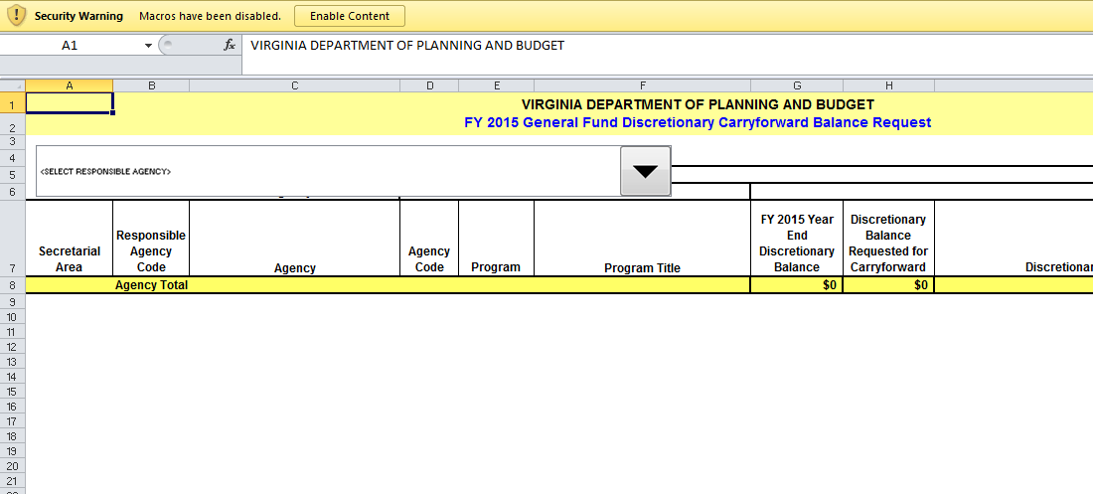
- Acknowledge the message. Select OK after reading the drop down box instruction.
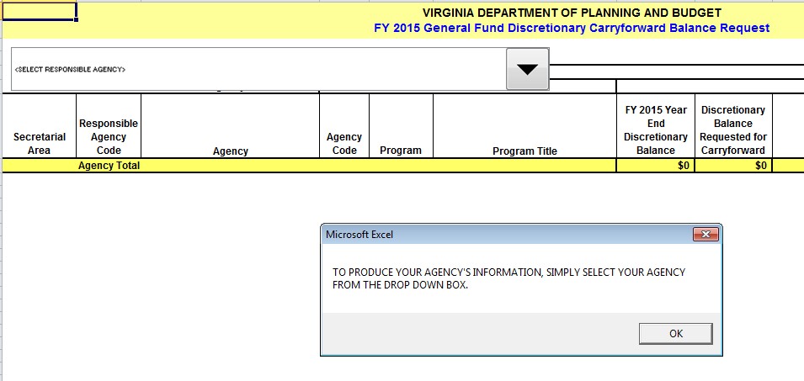
- Acknowledge any security warnings. At the top of the form, you should see a cell that asks you to select a responsible agency. Before you are able to make a selection, you may receive a Security Warning asking if you want to make this file a Trusted Document. If you receive the message, select “Yes”.
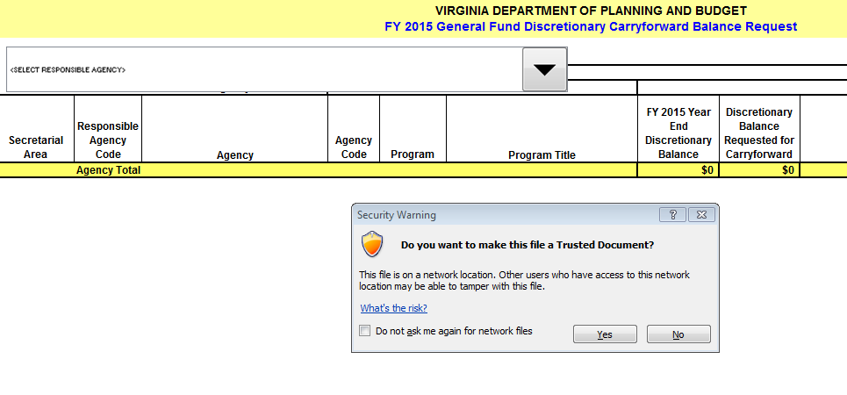
- Select your agency from the dropdown box. Select the responsible agency from the dropdown list in cell E3 (the cell has been pre-populated with “SELECT RESPONSIBLE AGENCY”). (NOTE: As an example of responsible agency, Agency 799 -Department of Corrections - is responsible for the budgets of all the Correctional Facility agencies; when the user selects agency 799, the template will be populated with all the Correctional Facilities having discretionary balances.

- Confirm Agency Selection. Select “Yes” after confirming the selected agency.
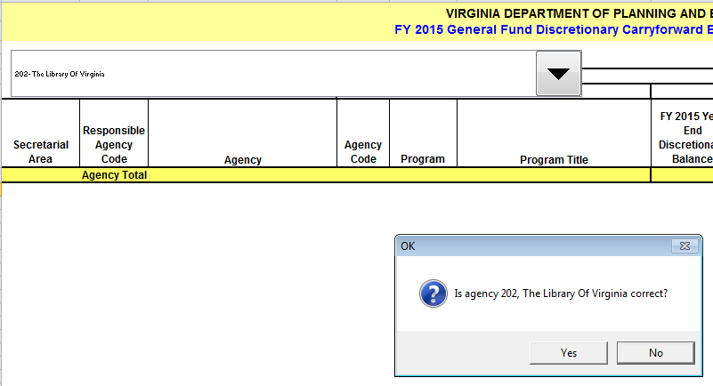
- Review the FY 2015 discretionary balances. After the agency selection is confirmed the spreadsheet will be populated with agency general fund balances by program code.
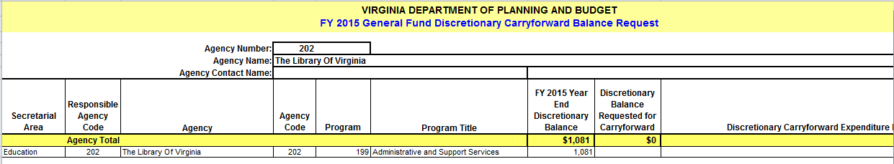

- SUBMISSIONS ARE ONLY REQUIRED FOR AGENCIES WISHING TO REQUEST DISCRETIONARY BALANCES BE REAPPROPRIATED. REMEMBER: IF A SUBMISSION IS NOT RECEIVED BY THE BUDGET EMAIL ACCOUNT BY THE DUE DATE, THE AGENCY’S DISCRETIONARY BALANCES WILL NOT BE CONSIDERED FOR REAPPROPRIATION.
- Complete Agency Contact Name. Provide an agency contact name for the submission.
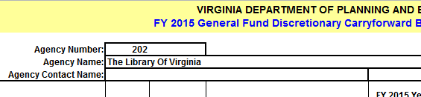

- For each balance item, input the requested discretionary balance. Enter an amount that is less than or equal to the Discretionary Balance.
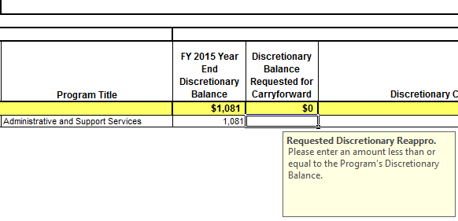
- For each balance item requested, input a brief expenditure plan. Enter a brief description of the proposed one-time expenditure. If you need assistance contact your DPB analyst.
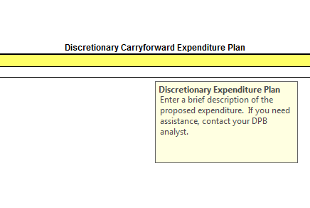

- Save the file. IMPORTANT: Save the file using the current name but add the responsible agency number at the end of the file name. See the example below:
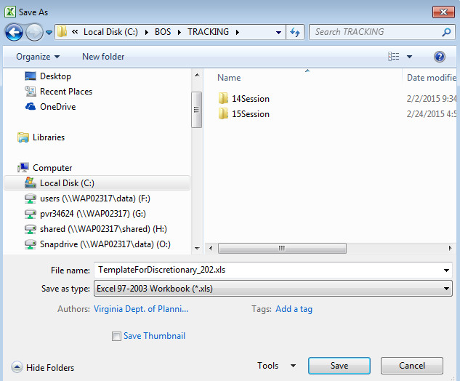
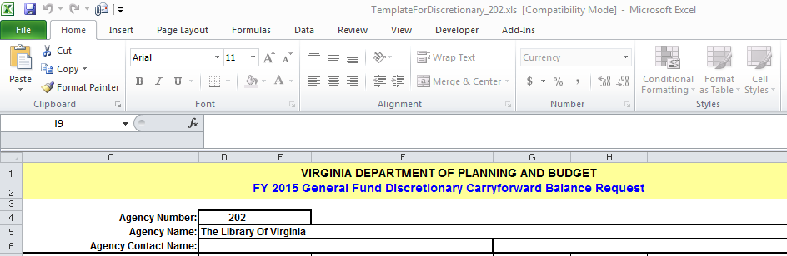

- Email the file to complete your submission. Email the file to DPB’s Budget email account and your DPB budget analyst. See below
